HADOOP CLOUDERA INSTALLATION STEPS ON VM

Master configuration=> 16GB RAM, 6 Core Processor, Disk Size 150 GB

Client configuration=> 4GB RAM, 4 Core Processor, Disk Size 60 GB

STEP-1

(i)First disable the firewalld

(ii) Vim /etc/selinux/conf

Enforcing changed to disabled

(iii) vim /etc/hosts

Ip master

Ip client

(iv) rsync /etc/hosts root@client:/etc/hosts

STEP-2=> Go to browser Cloudera manager

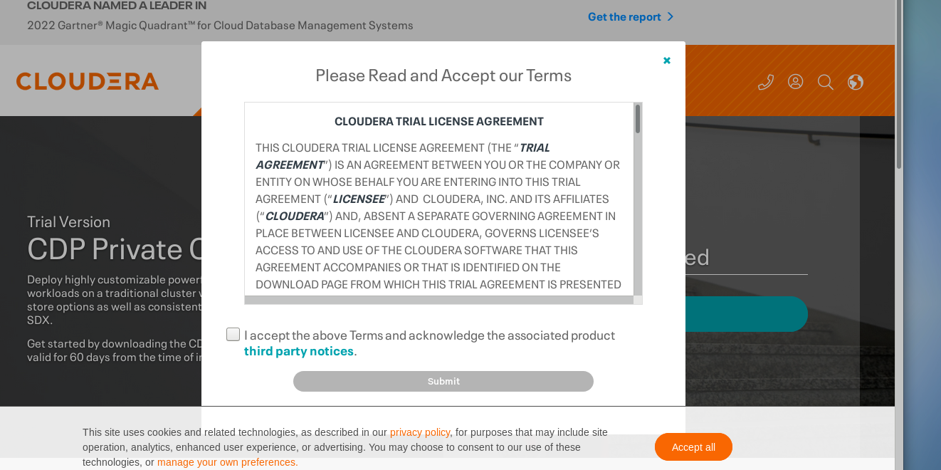

STEP-3=> Copy to the Linux command prompt to begin an automated CDP installation

STEP-4

STEP-5

STEP-6

STEP-7=> after installation click on close automatically browser will open

STEP-8=> username and password will be admin

STEP-9

STEP-10=> Enter the cluster Name

STEP-11=> Add the hostname and after that click on search

STEP-12

STEP-13=> select on install a cloudera-provided version of open JDK

STEP-14=> Enter the password and Continue

STEP-15

STEP-16

STEP-17

STEP-18=> select on I understand the risks of not running the inspections

STEP-19=> Select on custom services

STEP-20=> select HDFS,hive,hive on tez,spark,tez,yarn,yarn queue manager,Zookeeper

STEP-21

STEP-22

STEP-23

STEP-24

STEP-25

STEP-26

STEP-27

STEP-28

Now we have successfully installed Cloudera Manager on VM